# FUPR POF2

# Assessment Spring 2025 (30% of final grade)

|  |
| --- |
| Name: Bhumin Sabsrisupachai |

|  |
| --- |
| Candidate No: |

**Instructions**

Ensure you answer all the questions.

You must submit the report on Canvas.

**Declaration of originality**

By submitting this work, I declare that:

This assignment is my own original work, except where I have appropriately cited any original sources.

I have not sought help from anyone else, nor have I allowed my work to be copied.

I have not submitted this work as a summative assessment for any other module.

I will participate in academic integrity processes, including any online interviews by video conference, as required to confirm the submitted work is my own.

If you use any generative AI in the programming task you must indicate which AI you used and any prompts you used.

**For the sections where is says ‘In your own words’ generative AI may not be used.**

Students registered with the Disability Advice team and in receipt of reasonable adjustments are still permitted to use other assistive technology as required.

**Task One: Main Class**

The **Main class** is responsible for initializing the application and setting up the necessary components for launching the GUI.

**Tasks:**

1. Initialize the application.
2. Ensure seamless integration with InputForm and OutputForm.

**1.1 Paste your code here:**

package com.poohserver;  
  
import com.poohserver.model.NumberToWords;  
import com.poohserver.model.SpellChecker;  
import com.poohserver.view.InputForum;  
import com.poohserver.view.OutputForum;  
  
import javax.swing.*;  
import java.awt.*;  
import java.awt.event.ActionEvent;  
import java.awt.event.WindowAdapter;  
import java.awt.event.WindowEvent;  
  
public class MainFrame extends JFrame {  
 private CardLayout cardLayout;  
 private JPanel mainPanel;  
 private InputForum inputForum;  
 private OutputForum outputForum;  
 private JButton switchButton;  
 private SpellChecker spellChecker;  
 private boolean isInputForumVisible = true; // Track the currently visible panel  
  
 */**  
 * main frame constructor  
 */* public MainFrame() {  
 spellChecker = new SpellChecker("/home/pooh/Documents/sussex/furtherprogramming/le-gui-assesmentv2electric-bongaloo/Assets/test.txt");  
 spellChecker.setRandomSelect();  
 System.*out*.println(this.spellChecker.getRandomSelect());  
 setTitle("Main Application");  
 setSize(800, 400);  
 setDefaultCloseOperation(JFrame.*DO_NOTHING_ON_CLOSE*); // Handle closing manually  
 cardLayout = new CardLayout();  
 mainPanel = new JPanel(cardLayout);  
  
 inputForum = new InputForum("please spell out " + this.spellChecker.getRandomSelect(),this::windowSwitcher);  
 outputForum = new OutputForum("", this::windowSwitcher);  
  
 mainPanel.add(inputForum, "INPUT_FORUM");  
 mainPanel.add(outputForum, "ANOTHER_DISPLAY");  
  
 switchButton = new JButton("Switch Display");  
 switchButton.addActionListener(this::windowSwitcher);  
  
  
 getContentPane().setLayout(new BorderLayout());  
 getContentPane().add(mainPanel, BorderLayout.*CENTER*);  
  
 // Set the initial display  
 cardLayout.show(mainPanel, "INPUT_FORUM");  
  
 addWindowListener(new WindowAdapter() {  
 @Override  
 public void windowClosing(WindowEvent e) {  
 int choice = JOptionPane.*showConfirmDialog*(  
 MainFrame.this, "Are you sure you want to exit?", "Exit Confirmation",  
 JOptionPane.*YES_NO_OPTION*, JOptionPane.*WARNING_MESSAGE*);  
  
 if (choice == JOptionPane.*YES_OPTION*) {  
 System.*exit*(0);  
 }  
 }  
 });  
  
 setVisible(true);  
 }  
  
 */**  
 * this is a window switcher function and it also partially contorl the main program flow logic  
 * @param e ActionEvent  
 */* private void windowSwitcher(ActionEvent e){  
 if (isInputForumVisible) {  
 cardLayout.show(mainPanel, "ANOTHER_DISPLAY");  
 String msg = this.inputForum.getText();  
 System.*out*.println(msg);  
 boolean result = this.spellChecker.run(msg);  
 if (result){  
 this.outputForum.setTextMessage("correct");  
 this.outputForum.setIcon("/home/pooh/Documents/sussex/furtherprogramming/le-gui-assesmentv2electric-bongaloo/Assets/yes.png");  
 }  
 else {  
 this.outputForum.setTextMessage("WRONG The CorrectSpelling is: " + NumberToWords.*numberToWords*(this.spellChecker.getRandomSelect()));  
 this.outputForum.setIcon("/home/pooh/Documents/sussex/furtherprogramming/le-gui-assesmentv2electric-bongaloo/Assets/no.png");  
 }  
 isInputForumVisible = false;  
 } else {  
 this.spellChecker.setRandomSelect();  
 System.*out*.println(this.spellChecker.getRandomSelect());  
 this.inputForum.setLabelText("please spell out " + this.spellChecker.getRandomSelect());  
 cardLayout.show(mainPanel, "INPUT_FORUM");  
 isInputForumVisible = true;  
 }  
 }  
 // main entry point of the program  
 public static void main(String[] args) {  
 SwingUtilities.*invokeLater*(new Runnable() {  
 public void run() {  
 new MainFrame();  
 }  
 });  
 }  
}

Your code must be fully commented in your own words. [10 marks]

**Answer the following questions in your own words:**

* 1. How does the Main class initialize the application?

Via the main entry point of the program at the main method and starting the program with to ensure that the swing main thread is not running on the main program thread

SwingUtilities.*invokeLater*(new Runnable() {  
 public void run() {  
 new MainFrame();  
 }  
});

[5 marks]

* 1. How does the Main class ensure smooth navigation between InputForm and OutputForm?

*/**  
 * this is a window switcher function and it also partially contorl the main program flow logic  
 * @param e ActionEvent  
 */*private void windowSwitcher(ActionEvent e){  
 if (isInputForumVisible) {  
 cardLayout.show(mainPanel, "ANOTHER_DISPLAY");  
 String msg = this.inputForum.getText();  
 System.*out*.println(msg);  
 boolean result = this.spellChecker.run(msg);  
 if (result){  
 this.outputForum.setTextMessage("correct");  
 this.outputForum.setIcon("/home/pooh/Documents/sussex/furtherprogramming/le-gui-assesmentv2electric-bongaloo/Assets/yes.png");  
 }  
 else {  
 this.outputForum.setTextMessage("WRONG The CorrectSpelling is: " + NumberToWords.*numberToWords*(this.spellChecker.getRandomSelect()));  
 this.outputForum.setIcon("/home/pooh/Documents/sussex/furtherprogramming/le-gui-assesmentv2electric-bongaloo/Assets/no.png");  
 }  
 isInputForumVisible = false;  
 } else {  
 this.spellChecker.setRandomSelect();  
 System.*out*.println(this.spellChecker.getRandomSelect());  
 this.inputForum.setLabelText("please spell out " + this.spellChecker.getRandomSelect());  
 cardLayout.show(mainPanel, "INPUT_FORUM");  
 isInputForumVisible = true;  
 }  
}

[5marks]

**Task Two: InputForm Class**

The **InputForm class** presents a random number challenge and accepts user input.

**Tasks:**

1. Load the necessary resources such as the predefined source file containing random numbers (1-20).
2. Display a random number and prompt the user for input.
3. Accept user input via JTextField.
4. Validate user input and trigger the OutputForm.

**2.1 Paste your code here:**

package com.poohserver.view;  
  
import javax.swing.*;  
import java.awt.*;  
import java.awt.event.ActionListener;  
  
public class InputForum extends JPanel {  
 private JButton nextButton;  
 private JTextField textInput;  
 private JLabel label;  
 private String text;  
 private String labelText;  
  
 public InputForum(String startingText, ActionListener listener){  
 // Set layout with horizontal and vertical gaps  
 setLayout(new BorderLayout(10, 10));  
  
 // Set a kid-friendly pastel background color  
 setBackground(new Color(173, 216, 230)); // Light blue  
  
 this.labelText = startingText;  
  
 // Create and style the label  
 label = new JLabel(this.labelText, SwingConstants.*CENTER*);  
 label.setFont(new Font("Comic Sans MS", Font.*BOLD*, 28));  
 label.setForeground(new Color(255, 105, 180)); // Hot pink  
  
 // Create and style the text field  
 textInput = new JTextField();  
 textInput.setSize(30,40);  
 textInput.setFont(new Font("Comic Sans MS", Font.*PLAIN*, 68));  
 textInput.setBackground(Color.*WHITE*);  
 textInput.setForeground(Color.*BLACK*);  
 textInput.setBorder(BorderFactory.*createLineBorder*(new Color(255, 105, 180), 2));  
  
 // Create and style the button  
 nextButton = new JButton("Submit");  
 nextButton.setFont(new Font("Comic Sans MS", Font.*BOLD*, 24));  
 nextButton.setBackground(new Color(255, 182, 193)); // Light pink  
 nextButton.setForeground(Color.*DARK_GRAY*);  
 nextButton.addActionListener(listener);  
 nextButton.setFocusPainted(false);  
 nextButton.setBorder(BorderFactory.*createRaisedBevelBorder*());  
  
 // Add components to the panel  
 add(label, BorderLayout.*NORTH*);  
 add(textInput, BorderLayout.*CENTER*);  
 add(nextButton, BorderLayout.*EAST*);  
  
 // Increase the preferred size to make it more accessible  
 setPreferredSize(new Dimension(600, 100));  
 }  
  
 public String getText(){  
 this.text = textInput.getText();  
 return this.text;  
 }  
  
 public void setLabelText(String text){  
 this.labelText = text;  
 this.label.setText(this.labelText);  
 revalidate();  
 repaint();  
 }  
}

Your code must be fully commented in your own words.

[20 marks]

**2.2 Paste your output here:**

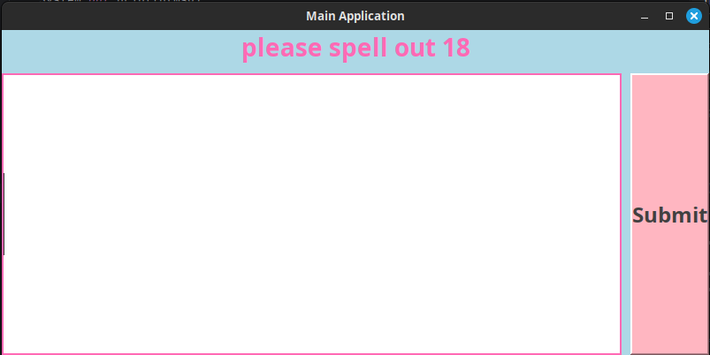

[7 marks]

**Answer the following questions in your own words:**

* 1. Why is it important to load numbers from a predefined source file?

A). to make the program more flexible. If you wan to add more number to the software you can just modify the source file instead of modifying the source code directly  
B).It in the spec of the software and good software engineer follow design spec

[3 marks]

* 1. What mechanisms are used to validate user input?

There is 2 main part 1 is to normalise the user input and the other one is to check if the number is spell correctly  
  
part 1 we remove the white space of the before the word and at the end of the word and make every letter become small case  
part 2 we then check if the string spelling is correct or not by checking if the word existed in the DICT (key value store) java and check IF the word is match is the number that it matched with have the selected random number

[3 marks]

* 1. How does the InputForm handle case-insensitive inputs?

part 1 we remove the white space of the before the word and at the end of the word and make every letter become small case  
 public static int wordsToNumber(String word) {  
 return *wordMap*.getOrDefault(word.toLowerCase().trim(), -1); // Return -1 if word not found  
 }  
}

[3 marks]

**Task Three: OutputForm Class**

The **OutputForm class** displays results and allows the user to retry or exit.

**Tasks:**

1. Display feedback based on the user’s input.
2. Provide a **Back or Retry** button to retry.
3. Provide a **Quit** button to exit the application.
4. Display an image if the answer is correct.

**3.1 Paste your code here:**

package com.poohserver.view;  
  
import javax.swing.*;  
import java.awt.*;  
import java.awt.event.ActionEvent;  
import java.awt.event.ActionListener;  
  
public class OutputForum extends JPanel {  
 private JLabel label;  
 private JButton optionA;  
 private JButton optionB;  
 private JLabel image;  
 private JLabel correctSpellinglable;  
  
 // Internal reference to the text.  
 private String textMessage;  
  
 */**  
 * this is a cponstructor method for the OutputFourm  
 * @param text this is a inital text message for the output forum  
 * @param e Action Listenner  
 */* public OutputForum(String text, ActionListener e) {  
 this.textMessage = text;  
 // Set a kid-friendly pastel background color.  
 setBackground(new Color(173, 216, 230)); // Light blue  
  
 // Create and style the label.  
 this.label = new JLabel(this.textMessage, SwingConstants.*CENTER*);  
 this.label.setFont(new Font("Comic Sans MS", Font.*BOLD*, 28));  
 this.label.setForeground(new Color(255, 105, 180)); // Hot pink  
  
 // Create and style the buttons.  
 this.optionA = new JButton("Exit");  
 this.optionB = new JButton("Try Again");  
 styleButton(optionA);  
 styleButton(optionB);  
  
 // Set up the image label.  
 this.image = new JLabel("", SwingConstants.*CENTER*);  
  
 // Set the panel layout to BorderLayout with gaps.  
 setLayout(new BorderLayout(10, 10));  
  
 // Add the label at the top.  
 add(label, BorderLayout.*NORTH*);  
  
 // Add the image in the center.  
 add(image, BorderLayout.*CENTER*);  
  
 // Create a panel for the buttons.  
 JPanel buttonPanel = new JPanel(new BorderLayout(10, 10));  
 buttonPanel.setBackground(new Color(173, 216, 230)); // Match background  
  
 // Add optionA to the west and optionB to the east.  
 buttonPanel.add(optionA, BorderLayout.*WEST*);  
 buttonPanel.add(optionB, BorderLayout.*EAST*);  
  
 // Add the button panel to the bottom.  
 add(buttonPanel, BorderLayout.*SOUTH*);  
  
 // Attach action listeners.  
 this.optionA.addActionListener(this::exitProgram);  
 this.optionB.addActionListener(e);  
 }  
  
 // Helper method to style buttons.  
 private void styleButton(JButton button) {  
 button.setFont(new Font("Comic Sans MS", Font.*BOLD*, 24));  
 button.setBackground(new Color(255, 182, 193)); // Light pink  
 button.setForeground(Color.*DARK_GRAY*);  
 button.setFocusPainted(false);  
 button.setBorder(BorderFactory.*createRaisedBevelBorder*());  
 }  
  
 */**  
 * icon setter method  
 * @param imagePath take the image path in  
 */* public void setIcon(String imagePath) {  
 ImageIcon icon = new ImageIcon(imagePath);  
 Image scaledImage = icon.getImage();  
 ImageIcon scaledIcon = new ImageIcon(scaledImage);  
 this.image.setIcon(scaledIcon);  
 this.revalidate();  
 this.repaint();  
 }  
  
 private void exitProgram(ActionEvent actionEvent) {  
 System.*out*.println("Exiting the program");  
 System.*exit*(0);  
 }  
  
 */**  
 * getter method  
 * @return Current text message String  
 */* public String getTextMessage() {  
 return textMessage;  
 }  
  
 */**  
 * settter function and repaint the lable  
 * @param textMessage  
 */* public void setTextMessage(String textMessage) {  
 this.textMessage = textMessage;  
 this.label.setText(textMessage);  
 this.revalidate();  
 this.repaint();  
 }  
}

Your code must be fully commented in your own words.

[20 marks]

**3.2 Paste your output here:**

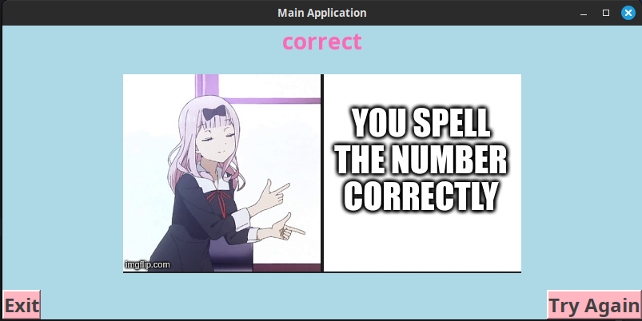

[7 marks]

**Answer the following questions in your own words:**

* 1. How does the OutputForm provide feedback to the user?

Via the use of Jlable to display the appropriate text and image to validate the user spelling

[3 marks]

* 1. How does the application ensure the Quit button properly exits both forms?

By using System.exit()  
addWindowListener(new WindowAdapter() {  
 @Override  
 public void windowClosing(WindowEvent e) {  
 int choice = JOptionPane.*showConfirmDialog*(  
 MainFrame.this, "Are you sure you want to exit?", "Exit Confirmation",  
 JOptionPane.*YES_NO_OPTION*, JOptionPane.*WARNING_MESSAGE*);  
  
 if (choice == JOptionPane.*YES_OPTION*) {  
 System.*exit*(0);  
 }  
 }  
});

[3 marks]

**Testing and Debugging**

* 1. How did you handle form transitions and event handling?

With cardlayout that embed jframe  
*/**  
 * this is a window switcher function and it also partially contorl the main program flow logic  
 * @param e ActionEvent  
 */*private void windowSwitcher(ActionEvent e){  
 if (isInputForumVisible) {  
 cardLayout.show(mainPanel, "ANOTHER_DISPLAY");  
 String msg = this.inputForum.getText();  
 System.*out*.println(msg);  
 boolean result = this.spellChecker.run(msg);  
 if (result){  
 this.outputForum.setTextMessage("correct");  
 this.outputForum.setIcon("/home/pooh/Documents/sussex/furtherprogramming/le-gui-assesmentv2electric-bongaloo/Assets/yes.png");  
 }  
 else {  
 this.outputForum.setTextMessage("WRONG The CorrectSpelling is: " + NumberToWords.*numberToWords*(this.spellChecker.getRandomSelect()));  
 this.outputForum.setIcon("/home/pooh/Documents/sussex/furtherprogramming/le-gui-assesmentv2electric-bongaloo/Assets/no.png");  
 }  
 isInputForumVisible = false;  
 } else {  
 this.spellChecker.setRandomSelect();  
 System.*out*.println(this.spellChecker.getRandomSelect());  
 this.inputForum.setLabelText("please spell out " + this.spellChecker.getRandomSelect());  
 cardLayout.show(mainPanel, "INPUT_FORUM");  
 isInputForumVisible = true;  
 }  
}

[3 marks]

* 1. What challenges did you encounter, and how did you resolve them?

The way dynamically switch between 2 forum automatically without killing the main window instead switching between the jpanel with the card layout

[3 marks]

* 1. Include sample test cases validating correctness.

Incorrect answer

Correct answer

improperly captalise spelling  
trailing white space   
starting whiteSpace

[5 marks]